OCTOBER NEWSLETTER ROOM 7

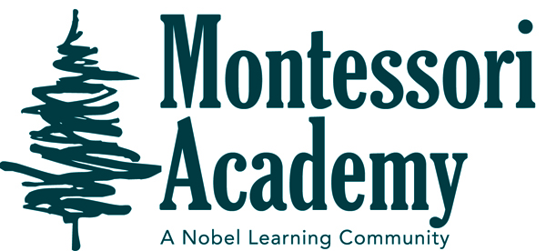
Dear Families,

IMPORTANT ALL SCHOOL DATES AND REMINDERS
MONTESSORI ACADEMY
IMPORTANT CLASSROOM DATES AND REMINDERS

Our year is off to a great start! Students are really
getting focused and working their way through the
classroom. We’ve been focusing on building communities and getting to know each other. We have begun shortwork, where for half an hour, students work on phonics, cursive practice, and math facts. We are studying the Universe and our solar system in Cultural. For math, we are working hard on the four brothers-addition, subtraction, multiplication, and division. If you haven’t gotten a chance to meet Ms. Anne, do so. She is our Reading Specialist, and the students love her. Every Wednesday, we have Author’s Chair, where the students get to read what they have been writing. Friday is Share Day, where they get to share an item from home based on their culture or from a trip that they took.

We are going to put together a virtual Wax Museum event on the 27th, 28th, and 29th of October. The students are so excited! We will travel through history learning about historical figures that have made a positive impact in the world. We hope to see everyone there via Zoom at 10:00 AM. Zoom numbers will be sent via email. The written assignment will be done at school, as well as the poster board. They may choose to dress up as their character and this will replace dressing up for Halloween costumes.

Sign-up for Parent/Teacher Conferences will go out later this month via email. We can’t wait to meet with you talk about your child. Please email with any questions!
aryn@montessoriacademyidaho.com
October 6th -7th Individual Student Pictures
October 22nd – 23rd Parent / Teacher Conferences
October 27th -29th Wax Museum

