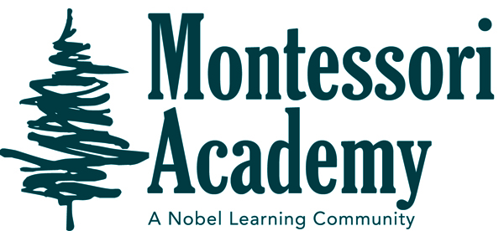
Dear Families,
November Newsletter Room 2
October’s Theme’s: Birthday’s
- North America Hunter’s 5 years
- Leaves Braxton’s 4 years
- Pumpkins

IMPORTANT ALL SCHOOL DATES AND REMINDERS
November 11th- Veterans Day No school
November 19th- Stone Soup
November 24h-26th No School Thanksgiving Break

MONTESSORI ACADEMY
IMPORTANT CLASSROOM DATES AND REMINDERS

As the weather starts to become cooler in the mornings, please send a jacket with your child to school for morning recess. This month we will be studying all about North America and leaves. We will be reading the Book Stone Soup this month. On November 19th we will having our annual stone soup lunch. There will be an email for you to sign up to bring an item.
Thanks,
Ms. Ashley

