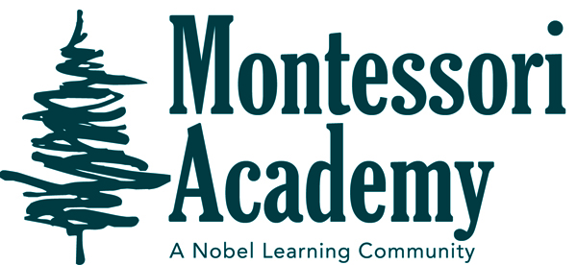Dear Families,

October Newsletter Room 2

October’s Theme’s:  **Birthday’s**

* Biomes Amelia’s 6 years
* Leaves Walter’s 3 years
* Pumpkins
* Mammals
* Skeletons

IMPORTANT ALL SCHOOL DATES AND REMINDERS

October 21st-22nd- Parent/teacher conferences. No school

October 29th- 9:15 am Costume parade

MONTESSORI ACADEMY

IMPORTANT CLASSROOM DATES AND REMINDERS

As the weather starts to become cooler in the mornings, please send a jacket with your child to school for morning recess. This month we will be studying about the different biomes, what mammals are and more. During the month we will be decorating a pumpkin as a class, and they will be available to view out front. On October 29th at 9:15am we will be having a costume parade around the parking lot. Your child may wear their costume to school over their school clothes. Please no face masks, face paint or weapons. We ask that you not park in front of the school for this event so that everyone will be able to see the children. October 21st and 22nd there is no school these days are for parent teacher conferences. I will be sending out more information soon about signing up for a spot.

Thanks,

Ms. Ashley