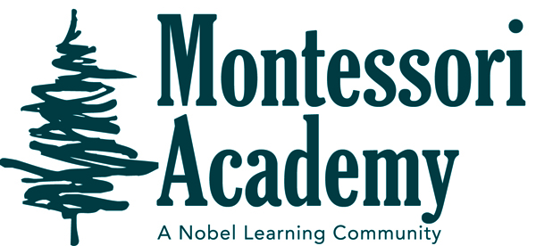
Dear Families
OCTOBER NEWSLETTER ROOM 4
I am looking for some volunteers that would be willing to come into the school once a week and listen to readers in the hallway, it would be great if I could get two helpers, let me know if you are interested.

Just so you know, those of you that have slippers in school they may get wet due to wet floors and fire drills, shoes are better option.

IMPORTANT ALL SCHOOL DATES AND REMINDERS
MONTESSORI ACADEMY
IMPORTANT CLASSROOM DATES AND REMINDERS
I am happy to report that the start of the year has been a success, not of course without a few bumps along the way, but that is the way it usually works. But we are off and running.
The children have all settled with what and how things work in and out of the classroom, with cubbies, lunch shelf, indoor shoes, and mailboxes.

Every year for the Halloween celebration the children have the opportunity to dress up in their costumes and participate in a parade around the school. The parade will take place on October 29th beginning at 9:15am, and they will parade outside around the parking lot so you can watch. Please have them wear their costume to school and bring a change of clothes in a bag.

Social/Emotional Concept # 2: Recognize and Express Feelings.
Children will develop an awareness of their feelings as well as the feelings in others through daily interactions with peers and adults. Children will develop the ability to effectively and appropriately express themselves and learn that their feelings and the feelings of others are important.
October 21st & 22nd Parent teacher conferences, Via Zoom
October 29th. Costume parade, beginning at 9:15 am
October 6 &. 7 individual pictures

